Maryland-National Capital Area Contingency Plan (MNCR-ACP)

Volunteer Management Plan

Annex G
May 2021.3

Record of Changes

Change Number | Change Description | Part Number | Change Date | Name
1
2
3
4
5
6
7
8
9
10

Table of Contents
1000 Introduction 1
2000 General Unified Command Considerations for Use of Volunteers 1
2100 Specific Volunteer Considerations for Oil Spill Response Missions 2
3000 Concept of Operations for Volunteers 3
3100 The Corporation for National and Community Service: An Option for Volunteer Management 4
3200 Unaffiliated Volunteer Management in Maryland 4
3210 Pre-Identified Volunteer Opportunities 4
3220 Volunteer Mission Tasking 5
3230 Volunteer Reception Center 6
3240 Affiliated Volunteer Organizations 6
3250 Training 7
3260 Public Information Officer-Joint Information Center (PIO-JIC) 7
3270 Volunteer Liability 8
3280 Volunteer Expenses 8
4000 ICS Roles and Responsibilities 8
4100 Unified Command 8
4200 Operations Section 9
4300 Planning Section 10
4400 Logistics Section 12
4500 Finance/Administration Section 12
5000 Local Government Operations 12
5100 Emergency Management Contact - Local Government Representative 12
5200 Emergency Operations Center 12
5300 Volunteer Reception Center 12
6000 Volunteer Responsibilities 13
6100 Affiliated Volunteers 13
6200 Unaffiliated Volunteers 14
6300 Affiliated Volunteer Organization (AVO) 14
6400 Community Based Organization (CBO) 14
6500 ICS ORGANIZATIONAL CHART 15
7000 Training Matrix 16
7100 Criteria 20
Appendix A: State & Local Government Emergency Manager Contact Information 21
Appendix B: Affiliated Volunteer Organization Contact Information 22
Appendix C UC Checklist 28
Appendix D Volunteer ICP Position Job Aids 30
Appendix E VRC Job Aid 35
Appendix F Volunteers and Oil Spill Response Brochure 46
Appendix G Draft Media Release 49
Appendix H Draft ICS-204 51
Appendix I ACRONYMS 54

1000 Introduction
Until recently, oil spill volunteers have not been utilized outside the care and processing of oiled wildlife, due to the health and safety hazards often present during an oil spill incident. This Volunteer Management Plan (VMP) has been developed for guidance to the Unified Command (UC) to consider the integration of volunteers into oil spill response for missions other than oiled wildlife. This volunteer guidance can also be used for responses other than oil spills.

- Affiliated volunteers: Individuals associated with an existing volunteer organization prior to an incident. They may have received sufficient training to allow them to function as part of that organization, although may not be trained for the specific type of response (i.e. oil spills, hazardous material releases, natural disaster, etc.). Local affiliated volunteers may be affiliated with either an Affiliated Volunteer Organization (AVO) or a Community Based Organization (CBO).
- Individuals, who spontaneously appear and would like to participate in the response effort, but have little or no training and are not part of an existing response organization.

A limited number of unaffiliated volunteers can be used in the care and processing of oiled wildlife
rehabilitation. The U.S. Fish and Wildlife Service, Maryland Department of Natural Resources, Virginia Department of Game and Inland Fisheries collaborate with Tri-State Bird Rescue and Research, Inc., and other participating wildlife organizations for oiled wildlife response. This function is in the Wildlife Branch reporting to the Operations Section Chief within the Incident Command System (ICS) organization. See Appendix B, for AVO Contact Information.

This plan is designed to assist the UC with guidelines to safely integrate volunteers into a response. It is not the intent of the VMP that volunteers replace government employees and or commercial responders. Instead the VMP serves as a tool to provide concerned citizens an opportunity to safely participate in the response.

In general, volunteers do not participate in oil spill responses. During an initial response when there has been no volunteer interest expressed, the ICS organization may not contain any positions specifically dedicated to volunteer management. As the UC becomes aware of individuals or organizations interested in providing volunteer services, the UC should address the issue and may make assignments for volunteer coordination within the ICS organization. This Volunteer Management Plan establishes volunteer management positions within the ICS organization that provide opportunities for concerned citizens while limiting the potential to hinder the UC and oil spill operations.

2000 General Unified Command Considerations for Use of Volunteers
Volunteer coordination in an incident offers complications not normally encountered in response. The UC should consider the following issues when deciding whether or not to utilize volunteers.

- The Planning, Operations, and Logistics Sections will need to incorporate volunteer efforts into many aspects of their duties. This paradigm shift will require time and effort during an Incident Command Post’s (ICP) daily routine.
- The timing of the Incident Action Planning (IAP) process could be more immediate than the lead time volunteer training and deployment might require. The cycles could be mismatched and difficult to manage.
- Unaffiliated volunteers are ‘just in time’ trained. This creates a higher risk of injury and liability than other responders who are trained and exercised on a regular basis.
- More risk and cost may occur in order to train volunteers at a minimum level, which could achieve a lower performance result at a higher threat to safety.
- Coordinating with local governments can be difficult to standardize. County, city, and town agencies, as well as local volunteer organizations, often have specialized operations and might not understand how to work within all response environments.
- Using volunteers at the ICP may create an information security risk.
- UC should be aware of any litigious issues between agencies and subsequent access to sensitive information.
- The responsibility of volunteer liability will need to be determined. The Responsible Party (RP) would most likely have unaffiliated volunteers sign a volunteer liability waiver prior to providing any assistance. Affiliated organizations typically have liability waivers for their own volunteers.

2100 Specific Volunteer Considerations for Oil Spill Response Missions
Unaffiliated volunteers do not usually participate in physical removal or remedial activities during oil spill response, and will not automatically be used for missions such as shoreline cleanup. It should be noted, at the outset and depending on the nature of the incident, volunteers may or may not be used to respond to an incident. The benefit of volunteer efforts must be weighed against concerns for volunteer safety. Based on the conditions specific to a particular incident, the UC will determine the suitability of integrating volunteers for oil spill response missions.

In reviewing the potential for use of volunteers in oil spill response missions, the UC will consider the following factors:

- Primary safety hazards (e.g. size, type and toxicity of discharged oil)
- Secondary safety hazards (e.g. rogue waves, tides, visibility, slips/trips/falls)
- Occupational Safety and Health Administration (OSHA) guidance
- U.S. Coast Guard Safety Manual
- Incident Site Safety and Health Plan (SSHP)
- Possible cleanup locations
- Logistics and administrative support requirements (e.g. training, personal protection equipment, multi-jurisdictional coordination, public information)
- State/Local government desire/ability to setup and manage Volunteer Reception Centers (VRC) and maintain a centralized Volunteer and Donations Management System (to manage offers of donated goods, monies, and volunteer services)
- Weather/tidal conditions
- How volunteers may effectively be used in shoreline cleanup

3000 Concept of Operations for Volunteers
The Liaison Officer (LNO) will generally be the first to receive external reports of volunteer interest due to the outreach responsibilities of that position. If volunteer interest exists, the LNO should determine the level of volunteer interest and pass that information on to the UC. If the UC decides to use volunteers, then the LNO will recommend the establishment of the Volunteer Coordinator, Unit Leader, or Officer based on the level of volunteer interest outlined below:

- LOW VOLUNTEER INTEREST: Establish a Volunteer Coordinator (VC) as a part of the Command Staff who will coordinate with local, regional, and state volunteer liaisons.
- MODERATE TO HEAVY VOLUNTEER INTEREST: A Volunteer Unit Leader (VUL) will be assigned and will report to the Planning Section Chief (PSC). The VUL will manage and coordinate the use of volunteers through collaboration with volunteer organizations.
- HEAVY VOLUNTEER INTEREST: The Command Staff shall be expanded to include a Volunteer Officer (VO) to coordinate with the LNO, and the Planning and Operations Sections. The VO shall closely coordinate volunteer needs and requirements with the PSC.

Once incorporated into the ICS organization, the Volunteer Coordinator, Unit Leader, or Officer will coordinate the review of Appendix C with the UC, General Staff, and appropriate Section Chiefs to determine when/how to use volunteers and recommend suitable volunteer tasks for the UC’s consideration and approval. The Volunteer Coordinator, Unit Leader, or Officer will coordinate outreach to state/local government emergency volunteer management systems and/or other Affiliated Volunteer Organizations (AVO) for activation of Volunteer Reception Centers and direction of volunteers to appropriate training sources. In each case, the Volunteer Coordinator, Unit Leader, or Officer will coordinate closely with the Joint Information Center (JIC), LNO and Public Information Officer (PIO) to publicize volunteer related information, such as alerts and training.

To align with state/regional/local government volunteer management systems, the Volunteer Coordinator, Unit Leader, or Officer can coordinate with the UC to establish the criteria for a Strike Team Leader (STLCR) to work with volunteers. This STLCR can assign a pre-established volunteer strike team. STLCRs working with volunteer groups will represent and provide the respective volunteer group status to the Staging Area Manager (STAM). This will be a crucial element in the tasking and deployment of volunteers in accordance with the IAP and ICS-204’s.

Once trained, volunteers will check-in with the Status Recorder at the appropriate check-in location. After they have checked in, volunteers may be deployed or remain in an availability status and/or staging area until tasked. Unlike other resources, volunteer availability and demobilization may be treated differently due to their inherent ‘at will’ nature. The Volunteer demobilization will be addressed in incident specific demobilization plan. The UC will provide logistical support to volunteers during a response.

See Appendix AA for State and Local Government Emergency Manager Contact Information and Affiliated Volunteer Organization Contact Information.

3100 The Corporation for National and Community Service: An Option for Volunteer Management
The Coast Guard and EPA recently signed an MOU with the Corporation for National and Community Service (CNCS), a federal agency specializing in unaffiliated volunteer management during disasters. CNCS support, in conjunction with state emergency management agency volunteer coordinators, may prove helpful in managing a large volunteer response. CNCS support is available through this MOU at the request of the Coast Guard or EPA OSC.

3200 Unaffiliated Volunteer Management in Maryland
For spills impacting Maryland shoreline in the Upper Chesapeake Bay, Potomac River, and associated tributaries, the Maryland Emergency Management Agency (MEMA) will take the lead in coordinating and managing the use of volunteers under the State Emergency Operations Plan’s ESF 15 – Donations and Volunteers. MEMA will designate a liaison to serve as the Volunteer Coordinator, Unit Leader, or Officer within the Incident Command Post (ICP) for the oil spill response.

3210 Pre-Identified Volunteer Opportunities
Human health and safety is the first priority in decisions regarding use of volunteers. Volunteers will
normally only be used in very low risk activities and only after receiving appropriate safety training. In most cases, affiliated volunteers may receive priority tasking before unaffiliated volunteers.

Once the decision to use volunteers is made, the UC will decide which volunteer tasks are appropriate
for that incident. The Volunteer Coordinator, Unit Leader, or Officer can use the task opportunity list
below to assist UC in making these decisions. The following is a list of roles for volunteers specific to
an oil spill response. Many of these roles would also be pertinent during different types of responses.
Please see section 7000: Training Matrix for training specifics.

PUBLIC INFORMATION OFFICER (PIO) SUPPORT
- Volunteer Information Brochure distribution

FINANCE/ADMINISTRATION SECTION
- ICP or VRC Volunteer Management Administrative Support
- ICP or VRC Administrative Support
- Distribution of Personal Protective Equipment (PPE)
- Procurement Support
- Time Unit
- Volunteer Time and Accounts Specialist

LOGISTICS SECTION
- Facility and Site Maintenance*
- Transport*
- Carpools*
- Scheduling
- Communications

PLANNING SECTION
- Volunteer Training Coordinator
- Technical Specialist/IT and/or Data Entry Specialist

OPERATIONS SECTION
- Volunteer Branch Director*
- Volunteer Group Supervisor*
- Shoreline Cleanup* ᵻ
- Pre-Impact Shoreline Cleanup ᵻ
- Wildlife Branch*
- Strike Team Leader*

* Indicates positions in which volunteers may be exposed to oil or need specific training (i.e. OSHA
requirements and/or wildlife rehabilitation training). Great consideration should be taken prior to
assigning volunteers to oil cleanup operations.

ᵻ The UC should consider the following shoreline cleanup tasking guidelines:
- Volunteers will NOT be deployed to work within Exclusion Zones.
- Volunteers will only be deployed to shorelines that have been characterized.
- Volunteers will not be deployed in the same locations as Oil Spill Removal Organizations
- (OSRO), Natural Resource Damage Assessment (NRDA), or Wildlife Search and Collection

Teams.
- Volunteers shall be escorted by authorized safety personnel.
- Volunteers will be trained according to Training Matrix guidelines.

3220 Volunteer Mission Tasking
Volunteer tasking will begin in the same manner as other resource tasking. During the preparation for the tactics meeting phase, the Operations Section Chief (OSC), Planning Section Chief (PSC), and Resource Unit Leader (RESL) will outline work assignments and determine the requisite volunteer resources. During the tactics meeting, the Safety Officer (SOFR) must determine safety and support needs for volunteers. Following the Planning meeting and the UC’s approval, the volunteer tasking will be incorporated into the Incident Action Plan (IAP). Upon completion of the IAP, the Branch or Division/Group Supervisor will convey to the appropriate Staging Area Manager the volunteer tasking assignments as delineated on the ICS-204, Assignment List.

3230 Volunteer Reception Center
A Volunteer Reception Center is a hub for matching potential volunteers with volunteer service
opportunities. The purpose of a VRC is to affiliate spontaneous volunteers with requesting agencies. VRCs may be administered by local governments alone if resources exist or in collaboration with a Volunteer Center or other AVO. VRCs have various capabilities and are primarily administrative
organizations with limited staff.

Most VRCs have the following capabilities:

- Can respond in an emergency and can staff up accordingly.
- Can receive, register and screen unaffiliated volunteers in person or via website and/or phone bank.
- Can train or facilitate volunteer training.
- Can conduct outreach to their identified community base and media outlets.
- Can coordinate with local AVOs and their affiliated volunteer base.
- Have pre-designated volunteer receiving and training areas.
- Can set up mobile volunteer receiving centers.

The Volunteer Coordinator, Unit Leader, or Officer should refer to the applicable Local Contingency Plan (LCP) for pre-identified VRCs. Note that not all localities have pre-identified VRCs.

Per the direction of the UC, a Volunteer Reception Center-Coordinator (VRC-C) position can be established. The decision to activate and setup a VRC shall be made by the local or state government. The VRC-C should work through the Liaison Officer and/or with local government representatives to activate their established VRC. If this is not possible, the VRC-C can work directly with a VRC. In addition to facilitating requisite volunteer training needs, the VRC-C will provide direction to the local VRC representative to organize volunteers into Strike Teams and assign a Strike Team Leader. See Appendix E, Volunteer Reception Center Job Aid from reference (c) for VRC Floor Plan and Staff Tasks.

It is recommended the STLCR be an experienced government employee or a person meeting UC’s qualifications. STLCRs shall have the safety training commensurate with the volunteer team’s assignment, be knowledgeable of oil spill cleanup operations and have experience supervising teams.

3240 Affiliated Volunteer Organizations
AVOs also referred to as, Non-Government Organizations (NGO), are organizations with a specific interest, which generally hold a non-profit or not-for-profit status. Usually the AVO interest is specific to the region, county or city area. AVOs attract volunteers within a community via their mutual interest. AVOs generally provide training, keep an affiliated volunteer database and have volunteer functions to facilitate current volunteer experience and communication. AVOs also accept donations of money or materials.

Most coastal localities have AVOs that focus on shoreline, wildlife and/or marine mammal interests. AVOs usually have the ability to reach out to a large segment of the public and can have great influence over public perception.

UC and Volunteer Coordinator, Unit Leader, or Officer coordination with AVOs can provide a source of affiliated volunteers to fulfill the needs of a response, as well as an organization to funnel volunteers into. If local government or a VRC is not able to assist in unaffiliated volunteer management, the Volunteer Coordinator, Unit Leader, or Officer can coordinate with AVOs to manage the influx of unaffiliated volunteers. Per the direction of the UC, an Affiliated Volunteer Organization-Coordinator (AVO-C) position can be established
.
See Appendix AA for AVO Contact Information.

3250 Training
The UC will determine the level of training needed for the volunteer tasks approved. The Safety Officer will review requisite training using OSHA standards as guidelines. If circumstances dictate, the UC may authorize incident specific training standards. See section 7000, Training Matrix, for volunteer training requirements.

3260 Public Information Officer-Joint Information Center (PIO-JIC)
Previous events have shown rapid media and public engagement is crucial to effectively managing public perception and volunteer efforts. Early and aggressive media engagement will not only keep the public informed but also alleviate perceptions of inaction, foster a better understanding of response operations, and provide direction to the public on various issues associated the incident. This is also a great opportunity to direct unaffiliated volunteers to AVOs involved in the event.

Press releases with general information – who, what, when, where, actions being taken – should be released as soon as possible. All public information released shall be verified by UC/JIC. Public information telephone hotline and website information should be established immediately and be included in all public information released. They should include health and safety notices, safety hazards associated with the event, oiled wildlife guidance, volunteer job opportunities, training requirements, and registration procedures. Unaffiliated volunteers will be encouraged to register with VA VOAD member organizations at 1-800-Volunteer or the Commonwealth’s Aid matrix Database System by calling the Volunteer and Donations Hotline which should be developed once the incident occurs. VRCs will also be able to register, screen, and place volunteers with AVOs.

During press conferences, public information talking points should stress the health, safety and environmental hazards associated with response operations, the importance of coordinated cleanup efforts, an understanding of site prioritization and how best the public can aid in the response. Public hotline numbers and website addresses are also key information to release in press conferences and as screen crawl information. See Appendix F for Volunteers and Oil Spill Response Brochure &
Appendix G for a Draft Media Release.

3270 Volunteer Liability
Because of the potential volunteer exposure to toxic substances, it is important that the UC comply with the standards established by the Area Contingency Plan and applicable laws, regulations, and policy in exercising its discretion in the use of volunteers. This plan clarifies the risk analysis to be conducted by the UC in deciding whether and how to employ volunteers to minimize potential liabilities of volunteers as well as federal, state, and local governments.
The determination to use volunteers is the responsibility of the UC. If the UC decides to utilize volunteers, the volunteers must check in at the VRC and/or with their affiliated volunteer organization and fill out the appropriate forms, attend health and safety training as well as job specific training as directed, and participate only in volunteer tasks approved by the UC. Individuals assisting without approval to do so may not be covered by local, state, and federal volunteer protection laws and assume significant risk.

If a volunteer is injured during a response, the SOFR and Volunteer Coordinator, Unit Leader, or Officer shall be notified. The volunteer should seek immediate medical assistance and provide personal health care insurance information to medical providers. The volunteer should also contact the Department of Labor for an assessment of Workman’s Compensation benefits eligibility. State workers compensation board information can be found at http://www.dol.gov/esa/owcp/contacts/feacont.htm.

3280 Volunteer Expenses
The Emergency Fund portion of the Oil Spill Liability Trust Fund (OSLTF) is available annually for
Federal response costs under the Clean Water Act. The OSLTF may be used to pay for volunteer
expenses consistent with this authority. Federal On-Scene Coordinators (FOSC) should consult with COMDT (CG-533) and the National Pollution Funds Center when dealing with issues regarding funding for volunteers.

4000 ICS Roles and Responsibilities
This section refers to and supports the Incident Management Handbook (IMH). Staff appointment to specific roles and responsibilities will be designated by the UC.

4100 Unified Command
Federal On-Scene Coordinator, State On-Scene Coordinator (SOSC), Local On-Scene Coordinator
(LOSC), Responsible Party

- Makes decision to use volunteers.
- Determines authorized volunteer jobs.
- Determines method and frequency of Volunteer updates to the UC.
- Works with Operations and Planning Sections to ensure effective use and management of volunteer operations.
- Works with Joint Information Center (JIC) to ensure appropriate public information is released in a timely manner.
- Works with Liaison Officer and/or Volunteer Coordinator, Unit Leader, or Officer to ensure volunteer needs are addressed.
- Consults with COMDT (CG-533) and the National Pollution Funds Center when dealing with issues regarding funding for volunteers.

Liaison Officer

- Refers local government agency reps to Volunteer Coordinator, Unit Leader, or Officer for any volunteer issues.
- Ensures volunteer efforts in the Volunteer Unit are communicated to the affected community via local government Agency Representatives and any feedback is received and relayed to the UC and Volunteer Coordinator, Unit Leader, or Officer.
- Provides volunteer hotline/website information to community stakeholders.
- Distributes prepared citizen/volunteer education packets to community stakeholders.
- Assists Volunteer Coordinator, Unit Leader, or Officer with Town Hall meetings as necessary.
- Coordinates with the Volunteer Coordinator, Unit Leader, or Officer to ensure the State Volunteer Representative can assist the Volunteer Coordinator, Unit Leader, or Officer as needed and has appropriate, timely information to share with the State Emergency Management Agency (VDEM or MEMA).
- Once the UC establishes an AVO-C, the Liaison Officer will shift all applicable AVO interaction to the AVO-C.

Public Information Officer

- Works with the JIC to ensure UC public messaging is communicated.
- Distributes prepared citizen/volunteer education packets and press releases to media, AVOs and other volunteer organizations. See Appendix G for a Draft Media Release.
- Considers pamphlet distribution at beach access point. See Appendix F for Volunteers in Oil Spill Response Brochure.

Safety Officer

- Ensures volunteers have appropriate training, PPE and volunteer site safety assignments.
- Ensures SSHP guidelines are followed.
- Ensure any volunteer injuries are immediately reported to the LNO and/or Volunteer
- Coordinator, Unit Leader, or Officer.

4200 Operations Section
Operations Section Chief

- Activates and supervises volunteer organizational elements in accordance with IAP.
- Directs implementation of volunteer operations.
- As necessary, expands the ICS structure to accommodate the use of volunteers.

Branch Director (OPBD)

- Ensures implementation of the volunteer portion of the IAP.

Division/Group Leader (DIVS)

- Ensures implementation of the volunteer portion of the IAP, appropriate to the Division/Group.

Strike Team Leader (STLCR)

- Works under respective DIVS to assist in volunteer operations and deployment and monitoring, focusing on volunteer access to and departure from assignment.
- Coordinates with other Strike Team Leaders, as necessary.
- Coordinates with and assists Assistant Safety Officer in volunteer logistical support.
- Meets volunteers at assigned shoreline, checks in/out volunteers, use ICS-204, ensures volunteers receive safety briefing per SSHP and distributes logistical support (PPE, food, water) if/when needed.
- Report any Volunteer injuries in accordance with approved Incident Safety Plan.

Staging Area Manager (STAM)

- Ensures volunteer check-in is ready.

4300 Planning Section
Planning Section Chief

- Establishes a Volunteer Unit (VU) when the UC authorizes the use of volunteers.
- Ensures the VU is appropriately staffed and supported.
- Remains cognizant of the volunteer roles in the event.

Situation Unit Leader (SITL)

- Ensures volunteer information is incorporated into the normal collection, processing, and organizations of information relating to the event.
- Ensures field observers are deployed to assigned operational volunteer locations.

Resources Unit Leader

- Ensures volunteers are fully incorporated into all Resource Unit activities.

- Coordinates with the Volunteer Coordinator, Unit Leader, or Officer to ensure accurate volunteer accountability and status.
- Check in/Status Recorder (SCKN)
- Receives, records, and maintains volunteer status information on Resource Status Cards (ICS-219) for incident-assigned volunteers and overhead volunteers.
- Volunteer Unit Leader (VUL)
- Once established, reports to the PSC.
- Ensures VU is appropriately staffed for the event size, including Technical Specialist assistance.
- Assigns VU Assistants as needed.
- Coordinates with the JIC on approved press releases, including volunteer hotline/website, appropriate and timely public messaging.
- Coordinates review of Appendix C, UC Checklist with UC and appropriate Section Chiefs and IC staff to determine when/how to use volunteers and recommends suitable volunteer tasks for UC consideration and approval.
- Provides volunteer status updates as directed by the UC, keeping the UC apprised of local and internal ICP sensitivities regarding volunteer issues.
- Works with LNO, Local Government Representative (LGR), and/or regional AVO to activate local government volunteer management systems.
- Weighs and considers all options regarding establishing AVO Coordinator (AVO-C) position.
- Works with Planning Section Chief, Operations Section Chief, and Logistics Section Chief to ensure effective and proper use of volunteers is included in the IAP.
- Ensures requests for volunteers are initiated and completed using Resource Request Form.
- Coordinates with Liaison Officer to ensure appropriate sharing of information in a timely manner with State Volunteer Coordinator and local government Agency Representatives.
- Coordinates with SOFR regarding any Volunteer injuries.

VRC Coordinator

- Once established, reports to Volunteer Coordinator, Unit Leader, or Officer.
- Coordinates outreach and VRC operations with local government.
- Ensures and facilitates requisite training is provided based on volunteer assignments.
- Coordinates with the JIC on Town Hall meetings.
- Ensures VRC’s are forming volunteer teams and assigned competent team leaders.

AVO Coordinator

- Once established, reports to Volunteer Coordinator, Unit Leader, or Officer.
- Coordinates outreach and AVO operations with local government.
- Ensures and facilitates requisite training is provided based on volunteer assignments.
- Coordinates with the JIC on Town Hall meetings.

Demobilization Unit Leader (DMOB)

- Ensures volunteers demobilization procedures, processes, and methodologies are established and fully incorporated into the DEMOB Plan.
- Works closely with Volunteer Coordinator, Unit Leader, or Officer on all aspects of volunteer demobilization.

4400 Logistics Section
Logistics Section Chief (LSC)

- Ensures volunteer activities are incorporated into all aspects of the Logistics Section.

4500 Finance/Administration Section
Finance Section Chief (FSC)

- Ensures volunteer participation is represented in all aspects of Finance Section.

5000 Local Government Operations
Depending on the incident’s impact on local government agencies, local government may or may not activate an Emergency Operations Center (EOC). EOCs can be activated at the County or City level. Under either circumstance, a LGR will report to the Liaison Officer.

5100 Emergency Management Contact - Local Government Representative

- Coordinates volunteer operations and messaging between UC and local government leadership.
- Works with Volunteer Coordinator, Unit Leader, or Officer and local government EOC staff to activate VRC operations, as requested by UC.
- Keeps UC informed of local volunteer situation.

5200 Emergency Operations Center

- Activates VRC operations as requested by Volunteer Coordinator, Unit Leader, or Officer.
- Establishes an EOC Volunteer Unit in Logistics to work with VRC operations.
- Works with Volunteer Coordinator, Unit Leader, or Officer and local VRC to convey volunteer mission tasking.
- Coordinates public messaging as appropriate.

5300 Volunteer Reception Center

- Coordinates with Volunteer Coordinator, Unit Leader, or Officer and local government to receive, register, and screen unaffiliated volunteers.
- Coordinates training operations to fulfill mission requests.
- Coordinates volunteer management with regional AVOs and their affiliated volunteers.
- Coordinates public outreach using approved public messaging from JIC/PIO.
- Provides status reports on volunteer management to Volunteer Coordinator, Unit Leader, or Officer and LGR

6000 Volunteer Responsibilities

6100 Affiliated Volunteers

- Will coordinate volunteer efforts through an AVO or local VRC.
- Volunteer efforts will be coordinated with the UC.

6200 Unaffiliated Volunteers

- Must be registered, screened and trained through local VRC or appropriate training source.
- After completion of training, may be assigned to a volunteer task via the UC.

6300 Affiliated Volunteer Organization (AVO)

- Will coordinate volunteer efforts through local VRC and/or Volunteer Coordinator, Unit Leader, or Officer.

6400 Community Based Organization (CBO)

- Will coordinate volunteer efforts through local VRC, AVO and/or Volunteer Coordinator, Unit Leader, or Officer.

6500 ICS ORGANIZATIONAL CHART
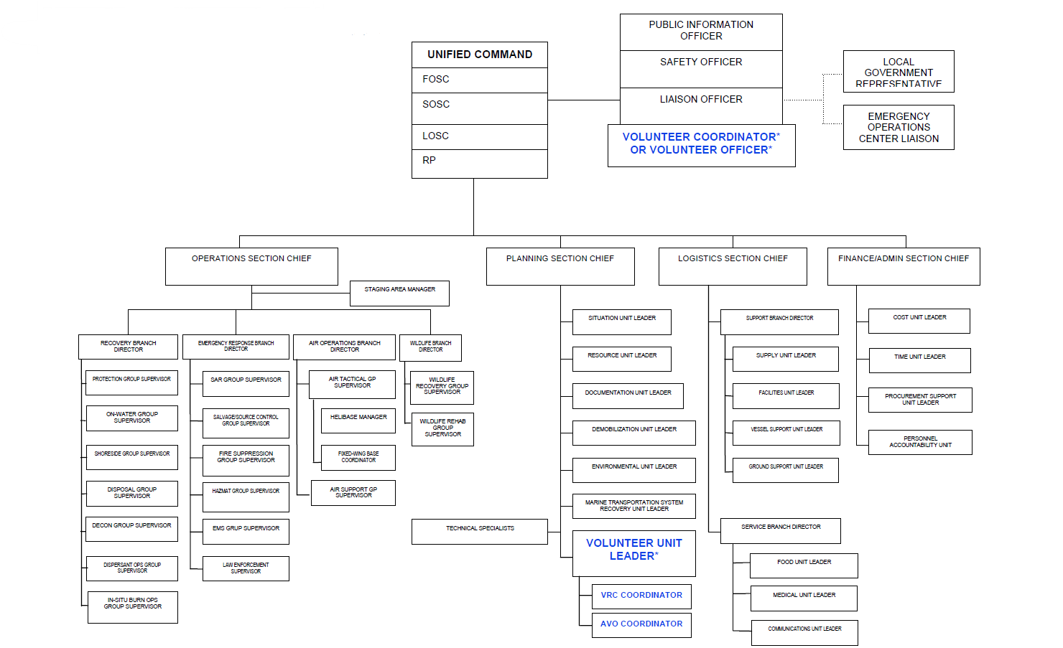

* Positions dependent upon the level of volunteer interest – see Section 3000, Concept of Operations for Volunteers.

7000 Training Matrix
Position Descriptions for:

- Volunteer Management Staff (non-volunteer positions), and for
- Affiliated and Unaffiliated Non-Wildlife Volunteers

Volunteer assignments could be made to:

- (ICP) Incident Command Post (limited opportunities)
- (VRC) Volunteer Reception Center (many opportunities)
- (Field) Field (limited opportunities, some of which will be limited to pre-trained volunteers)

Appropriate training, based on assigned tasks, shall be provided to volunteers prior to participation in response operations. Reference (d), the National Oil and Hazardous Substances Pollution Contingency Plan (NCP), 40 CFR Part 300, discourages volunteer participation in physical removal activities and limits them to the non-hazardous tasks due to extensive medical surveillance, training, and equipment required for participating in physical removal activities.

Unaffiliated volunteer assignments will only be made to areas which have been monitored and fully characterized indicating that exposures are under permissible exposure limits (PEL) and published exposure levels where respirators are not necessary, and the characterization indicates that there are no health hazards or the possibility of an emergency developing.

Affiliated volunteers who do take part in removal operations involving hazardous substances must be trained in accordance with Hazardous Waste Operations and Emergency Response (HAZWOPER) Standards set forth by Emergency Response to Hazardous Substances Releases, 29 CFR 1910.120(q) requirements and any applicable state plan requirements.

Additional guidance regarding HAZWOPER training requirements can be found in reference (e) available online at: http://www.osha.gov/Publications/3172/3172.html.

To ensure volunteers integrate into the ICS organization smoothly, all volunteers must at a minimum provide documentation of IS100 and IS700 training prior to being assigned a role in the ICS or on the Incident Management Team (IMT).

These required trainings are free at http://training.fema.gov/IS/. In order to volunteer during an oil spill incident, the following requirements MUST be fulfilled*:

- At least 18 years of age
- Be in good health
- Able to lift 25-35 pounds
- Fill out Volunteer Registration Form (which may include Volunteer Liability Waiver)
- Complete health and safety training requirements

* Exceptions to these requirements may be made on a case-by-case basis for certain jobs/tasks that do not require ICS training or physical abilities in the response such as serving as a greeter at the VRC, handing out water to responders, or passing out information brochures to the public.

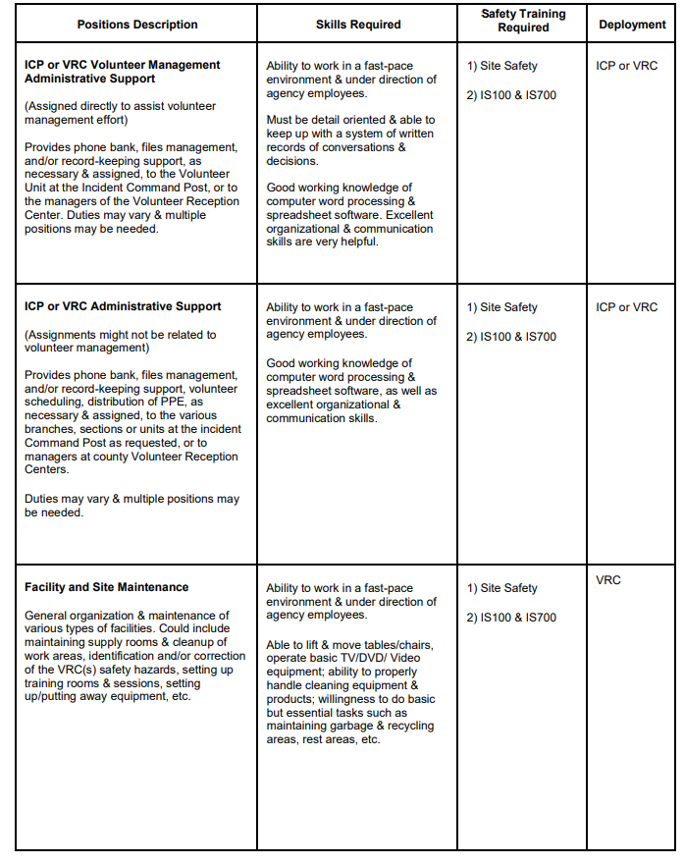
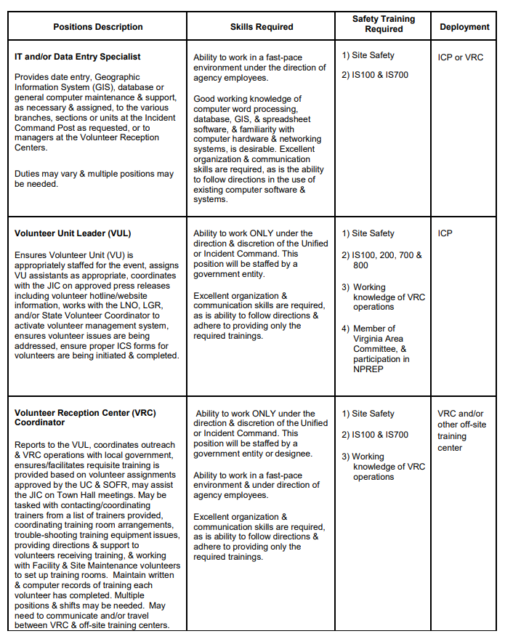
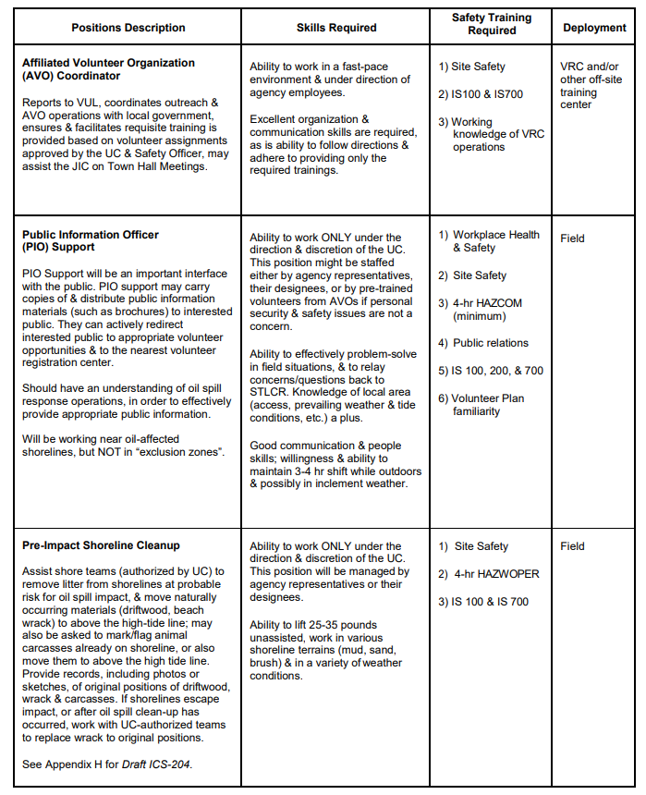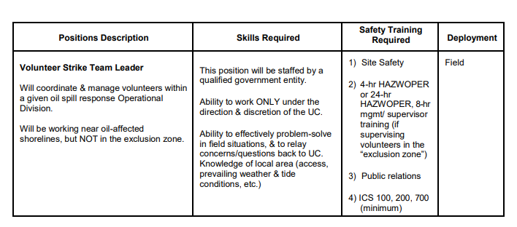

7100 Criteria
4-Hour HAZWOPER Training Requirements:

All of the following criteria must be met in order to use 4-hr minimum training:

- Clean-up is performed in an area that has been monitored and fully characterized by a qualified person indicating that exposures are presently and can be expected to remain under permissible exposure limits and other published exposure limits;
- Health risks from skin absorption are minimal;
- Personnel have completed the training requirements of Emergency Action Plans and Hazard Communication, including refresher training as appropriate;
- Personnel have completed other safety and health training made necessary by the tasks they are expected to perform such as, but not limited to, operating procedures, decontamination procedures, water safety, hypothermia, heat stress, and safety hazard controls;
- There is adequate on-site supervision by employees who have completed the HAZWOPER 24-hr or 40-hr initial training, and the 8-hr Mgmt/Supervisor training.
- Personnel will also receive continuous on-the-job training (OJT) by qualified supervisors

Appendix A: State & Local Government Emergency Manager Contact Information

MARYLAND DEPARTMET OF EMERGENCY MANAGEMENT (MDEM)
Address: 7229 Parkway Drive, Suite 200, Hanover, MD 21076
Phone: 1-877-686-2872, 410-517-3600
Web: https://mdem.maryland.gov/Pages/home-12345.aspx

Maryland Emergency Operations Plan:
https://mdem.maryland.gov/documents/srop_v3_03_mar-15.pdf

Maryland Joint Operations Center (MJOC)
Address: 7229 Parkway Drive Hanover, MD. 21076
Phone: 410-517-3600

ESF-15 Volunteers & Donations/Citizen Corps:
Erika Summers
Email: erika.summers@maryland.gov

Directory of Maryland Local Emergency Managers:
https://mdem.maryland.gov/pages/emmgrs.aspx

VIRGINIA DEPARTMENT OF EMERGENCY MANAGEMENT (VDEM)
Address: 10501 Trade Court, Richmond, VA 23236 Phone: 804-897-6500 (Switchboard Number)
Web: http://www.vaemergency.com/ or http://www.vdem.state.va.us/

Virginia Emergency Operations Plan: http://www.vaemergency.com/library/plans/

Virginia Emergency Operations Center
Address: 7700 Midlothian Turnpike, Richmond, VA 23235
Phone: 1-800-468-8892 (Toll-free), 804-674-2400 (Switchboard Number) Email: VEOC@vdem.virginia.gov

Voluntary Agency Liaison / ESF-17 Volunteers & Donations: Terry Raines Phone: 804-922-0455
Email: Terry.Raines@vdem.virginia.gov
Citizen Corp/CERT Training and Outreach Coordinator: TBD Phone: TBD
Email: TBD

Directory of Virginia Local Emergency Managers:
http://www.vaemergency.com/library/directories/index.cfm

Appendix B: Affiliated Volunteer Organization Contact Information

Volunteer Centers in Maryland

For more information on volunteer centers in Maryland visit the Maryland Volunteer
Centers website at http://www.marylandvolunteercenters.org.

Volunteer Southern Maryland
Address: 8730 Mitchell Rd, P.O. Box 910 La Plata, MD 20646
Phone: 301-934-7642
Email: volunteer@csmd.edu Web: http://www.csmd.edu/vsmd/
Areas Served: Calvert, Charles, and St. Mary’s counties

United Way of Calvert County Volunteer Resource Center
President & CEO: Kelly Chambers Address: P.O. Box 560
Prince Fredrick, MD 20678 Phone: 410-286-0100
Fax: 410-535-8987
Email: kelly.chambers@unitedwaycalvert.org Web: http://www.unitedwaycalvert.org/
Areas Served: Calvert County

Volunteer Center for Anne Arundel County Director: Fay Mauro Address: 2666 Riva Rd Annapolis, MD 21401
Phone: 410-897-9207
Fax: 410-222-4589
Email: fay@volunteerannearundel.org Web: http://www.volunteerannearundel.org/ Areas Served: Anne Arundel County

BVU’s Volunteer Central Director: Kelly Hodge-Williams Address: 175 W Ostend St Ste 100 Baltimore, Maryland 21230-3701
Phone: 410-366-6030
Fax: 410-366-6032
Email: information@volunteercentral.net Web: http://www.volunteercentral.net/ Areas Served: Greater Baltimore Area

Baltimore County Volunteers Address: 400 Washington Ave Towson, MD 21204
Phone: 410-887-2715
Email: volunteers@baltimorecountymd.gov Web: http://www.baltimorecountymd.gov/Agencies/vol unteers/index.html
Areas Served: Baltimore County

Chesapeake Volunteer Center
Director: Marci Leach Address: 1000 College Circle Wye Mills, MD 21679
Phone: 410-827-5440
Email: mleach@chesapeake.edu
Web: http://www.chesapeake.edu/volunteer/ Areas Served: Caroline, Dorchester, Kent, Queen Anne’s, and Talbot counties

ShoreCAN Volunteer Center
Address: 1324 Belmont Ave, Suite 401
Salisbury, MD 21804
Phone: 410-742-9911
Fax: 410-742-6638
Email: shorecan@cfes.org Web: http://www.shorecan.org/
Areas Served: Somerset County, Wicomico County, Worcester County

Worcester County
Volunteer Services Program
Volunteer Services Manager: Cyndy Howell Address: 1 W Market St, Courthouse Rm 1301, Snowhill, MD 21863
Phone: 410-632-5656
Fax: 410-632-5614
Email: chowell@co.worcester.md.us Web:
http://www.co.worcester.md.us/volunteerservice s.htm
Areas Served: Worchester County

NORTHEAST VIRGINIA
For more information on volunteer centers in Virginia visit the Points of Light Foundation
website at www.pointsoflight.org.

Rappahannock United Way
Director: Sarah Walsh
Address: 3331 Shannon Airport Circle Fredericksburg, VA 22408
Phone: 540-371-5268
Toll Free: 877-435-7510
Fax: 540-373-0356
Email: wecare@rappahannockunitedway.org
Web: http://www.rappahannockunitedway.org
Areas Served: Fredericksburg City, Caroline County, King George County, Spotsylvania County and Stafford County

Voluntary Action Center of the Prince William Area, Inc.
Director: Mary E. Foley
Address: 9248 Center St Manassas, VA 20110
Phone: 703-369-5292
Fax: 703-369-5671
Email: mfoley@volunteerprincewilliam.org
Web: http://www.volunteerprincewilliam.org
Areas Served: Manassas, Manassas Park, Prince William County

Volunteer Alexandria
Director: Melinda Patrician
Address: 123 North Alfred St. Alexandria, VA 22314
Phone: 703-836-2176
Fax: 703-683-1793
Email: mpatrician@volunteeralexandria.org
Web: http://www.volunteeralexandria.org/
Areas Served: Alexandria, Fairfax County

Volunteer Arlington
Director: Greg Castano
Address: 3033 Wilson Blvd #300B Arlington, VA 22201
Phone: 703-228-1760
Fax: 703-228-1013
Email: volunteer@arlingtonva.us
Web: http://www.arlingtonva.us/volunteer Areas Served: Arlington County

Volunteer Fairfax
Director: Jeanne Sanders
Address: 10530 Page Ave Fairfax, VA 22030
Phone: 703-246-3460
Fax: 703-246-4662
Email: jsanders@volunteerfairfax.org
Web: http://www.volunteerfairfax.org
Areas Served: Fairfax County, including Falls Church, Fairfax City, Herndon, Vienna and
Clifton

Affiliated Non-Wildlife Volunteer Organizations

Maryland Voluntary Organizations Active in Disaster (MD VOAD)

Maryland VOAD
MD VOAD Representative: Mickey Gomez, Volunteer Center Serving Howard County Address: 10221 Wincopin Circle, Columbia, MD 21044
Phone: 410-715-3176
Email: mickey@volunteerhoward.org Web: http://www.mdvoad.org/index.htm
Areas Served: Lead VOAD for the State of Maryland

Maryland Citizen Corps

Maryland Citizen Corps Council
Program Manager: Robert Ward, Maryland Emergency Management Agency Address: 5401 Rue Saint Lo Drive, Reisterstown, MD 21136
Phone: 410-517-3606
Email: rward@mema.state.md.us
Web: http://www.citizencorps.gov/cc/CouncilMapIndex.do?submitState&state=MD

Virginia Voluntary Organizations Active in Disaster (VA VOAD)

Virginia VOAD
VA VOAD Representative: Jon Barton, Virginia Council of Churches Address: 1214 West Graham Rd, Suite 3, Richmond, VA 23220
Phone: 804-321-3300 (Office), 804-615-2197 (Cell), 804-329-5066 (Fax)
Email: barton@vacouncilofchurches.org
Web: http://vacouncilofchurches.org/cms/index.php?option=com_content&task=view&id=26&Itemid=105 ; http://www.vavoad.com/
Areas Served: Lead VOAD for the State of Virginia

Northern Virginia Regional VOAD VOAD Representative: Lewis Saylor Phone: 703-955-6310
Email: novavoad@yahoo.com, sayjls@aol.com
Web: http://www.vavoad.com/Home/NorthernVirginiaRegionalVOAD/tabid/77/Default.aspx
Areas Served: Counties of Arlington, Fairfax, Loudoun, Prince William, and the Cities of Alexandria, Fairfax, Falls Church, Manassas, Manassas Park

Rappahannock Regional VOAD
Address: Rappahannock United Way, P.O. Box 398, Fredericksburg, VA 23404 Phone: 540-373-0041 x314
Email: sbeck@rappahannockunitedway.org
Web: http://www.vavoad.com/Home/RappahannockRegionalVOAD/tabid/78/Default.aspx
Areas Served: Counties of Caroline, King George, Spotsylvania, Stafford and the City of Fredericksburg

Virginia Citizen Corps

Virginia Citizen Corps Council Program Manager: Linda Rubin Address: VDEM, 10501 Trade Court Richmond, VA 23236
Phone: 804-897-6500 x6594
Fax: 804-897-6506
Email: linda.rubin@vdem.virginia.gov
Web: http://www.citizencorps.gov/cc/CouncilMapIndex.do?submitState&state=VA

Citizen Corps Partner Programs and Affiliates

Community Emergency Response Teams (CERT): http://www.citizencorps.gov/cert/ Volunteers in Police Service (VIPS): http://www.policevolunteers.org/
Fire Corps: http://www.firecorps.org/
Medical Reserve Corps (MRC): http://www.medicalreservecorps.gov/HomePage

Operation Blessing International

Director: Jody Herrington
Address: 977 Centerville Turnpike, Virginia Beach, VA 23463
Phone: 757-226-3401 (Main Office), 757-226-3433 (Director Office), 757-376-9460 (Director Cell) Fax: 757-226-3657 (Main Office), 757-277-0231 (Director)
Email: jody.herrington@ob.org Web: http://www.ob.org/
Areas Served: World-wide
Capabilities: Communications, Cranes/Loaders, Construction Trailers, Feeding Equipment, Transportation, Support Vehicles, Power Support, Power Supply, Medical Operations, Water Support

Chesapeake Bay Foundation
http://www.cbf.org/ or 1-888-SAVEBAY

Headquarters and Maryland State Office
Philip Merrill Environmental Center 6 Herndon Avenue
Annapolis, MD 21403
Phone: 410-268-8816
Fax: 410-268-6687

Salisbury, Maryland, Office
212 West Main Street, Suite 204B Salisbury, MD 21801
Phone: 410-543-1999
Fax: 410-546-3283

District of Columbia - Federal Affairs Office
725 8th Street, SE Washington, DC 20003
Phone: 202-544-2232
Fax: 202-544-2234
United Way
http://www.liveunited.org/ or 703-836-7112

Maryland State Association of United Ways
Address: PO Box 1576, C/o United Way of Central Maryland, Baltimore, MD 21203-1576 Phone: 410-895-1477
Website: http://www.liveunited.org/myuw/local.cfm?id=browsecities&zip=00000&abbr=MD&app

Wildlife Rescue & Rehabilitation Volunteer Organizations

Tri-State Bird Rescue and Research
Director: Heidi Stout
Address: 110 Possum Hollow Rd Newark, DE, 19711
Phone: 302-737-9543
Email: HStout@tristatebird.org Web: http://www.tristatebird.org/
Specialization: Birds

Maryland Department of Natural Resources
Address: 580 Taylor Ave Annapolis, MD
Phone: 877-463-6497 (Toll-free), 410-260-8940
*24-hour line that provides names and numbers of licensed wildlife rehabilitators Web:http://www.dnr.maryland.gov/wildlife/Plants_W ildlife/sickorinjured.asp

Specialization: Regional Wildlife

Wildlife Response Inc. (Maryland)
Address: P.O. Box 330 Monkton, MD 21111
Phone: 443-507-0950
Web: http://www.wildliferescueinc.org/
Specialization: Regional Wildlife

Sanctuary House
Address: 27548 Fairmount Road, P.O. Box 143 Upper Fairmount, MD 21867
Phone: 410-621-0709
Web: http://www.dioceseofeaston.org/cota3a.html
Specialization: Birds

Virginia Aquarium Stranding Response
Director: Mark Swingle
Address: 717 General Booth Blvd Virginia Beach, VA 23451 Phone: 757-437-6159
Fax: 757-437-4933
Web: http://www.virginiaaquarium.com/research-conservation/Pages/stranding-response-program.aspx
Specialization: Marine Mammals

Virginia Beach SPCA Wildlife Program
Director: Virginia Tavenner Address: 3040 Holland Rd Virginia Beach, VA 23453
Phone: 757-427-6387 or 757-485-9933 (Option 2)
Email: info@vbspca.com
Web: http://vbspcawildlife.com/ Specialization: Regional Wildlife

Wildlife Response Inc. (Virginia) Address: P.O. Box 2904 Chesapeake, Virginia 23327
Phone: 757-543-7000
Web: http://www.wildliferesponse.org/
Specialization: Regional Wildlife

Appendix C UC Checklist

Incident Name: Date:

PURPOSE: This job aid is intended to aid the Unified Command (UC) in deciding whether or not volunteers shall be used during an oil spill event and in what roles they may serve.

REFERENCES: Below is a list of references that may be required while using this job aid:

- Maryland Area Contingency Plan, Volunteer Management Plan.
- Upper Chesapeake Bay Estuary Area Contingency Plan, Use of Volunteers in Oil Spill Response Annex.

Volunteer Policy: Volunteers will not automatically be used. The benefit of volunteer efforts must be weighed against concerns for volunteer safety. Based on the conditions specific to that incident, the UC must determine the suitability of integrating volunteers into an oil spill response.

The UC will consider the following factors when considering the use of volunteers:
- Primary safety hazards (size, type and toxicity of discharged oil).
- Secondary safety hazards (rogue waves, tides, visibility, slips/trips/falls).
- OSHA guidance.
- Coast Guard Safety Manual.
- Incident Site Safety Plan.
- Possible cleanup locations.
- Logistics and administrative support requirements (training, PPE, multi-jurisdictional coordination, public information).
- Local government desire/ability to activate an emergency volunteer management system (including Volunteer Reception Center, recruiting, administering, training, deployment, recovery/decon).
- Weather/tidal conditions.
- How volunteers can effectively be used in shoreline cleanup.
Volunteers will normally be used in very low risk activities and only after receiving appropriate safety training. Volunteers with documented specialized training will be given higher priority for use.

UNIFIED COMMAND Volunteer Decision List:
- Decision to use volunteers. □ Yes □ No
- Determine authorized volunteer jobs. (See page2)
- Determine method & frequency of volunteer updates to the UC.
Method: Frequency:
- Determine method and time of volunteer information message release:
Method: Time:

The following are the Volunteer Job Opportunities authorized by the UC for
(incident name) event/response. (Checked boxes indicate the UC authorizations of job for volunteers.)
Public Information Officer (PIO) Support
□ Volunteer Information Brochure distribution
Finance/Admin Section
- ICP or VRC Volunteer Management Administrative Support
- ICP or VRC Administrative Support
- Distribution of Personal Protective Equipment (PPE)
- Procurement Support
- Time Unit
- Volunteer Time and Accounts Specialist
Logistics Section
- Facility and Site Maintenance*
- Transport*
- Carpools*
- Scheduling
- Communications
Planning Section
- Volunteer Training Coordinator
- Technical Specialist/IT and/or Data Entry Specialist
Operations Section
- Volunteer Branch Director*
- Volunteer Group Supervisor*
- Shoreline Cleanup*
- Pre-Impact Shoreline Cleanup
- Wildlife Branch*
- Strike Team Leader*
*Indicates that person maybe exposed to oil or need specific training (i.e. OSHA requirements and/or wildlife rehabilitation training).

UC guidance, instructions or restrictions for volunteers:

Appendix D Volunteer ICP Position Job Aids

VOLUNTEER UNIT LEADER (VUL)

READ THIS ENTIRE POSITION JOB AID BEFORE TAKING ACTION

Report To: Planning Section Chief

Responsibilities

- Review Common Responsibilities in Chapter 2 of the U.S. Coast Guard Incident Management Handbook (IMH).
- Review Common Unit Leader Responsibilities in Chapter 2 of the IMH.
- Monitor work progress and make changes when necessary.
- Coordinate with Liaison to keep UC, JIC and Planning Chief apprised of volunteer interest and affected area’s political leadership position on use of volunteers.
- Be ready to facilitate UC decision to use volunteers in capacity determined appropriate.
- Coordinate with Liaison and LGR regarding local government unaffiliated volunteer management resources.
- Coordinate with regional Affiliated Volunteer Organizations (AVO) regarding volunteer information and affiliated volunteer management resources.
- Coordinate with JIC regarding outgoing volunteer messaging.
- Ensure UC Sections, Branches and Units are coordinating with volunteer effort, as appropriate.
- Coordinate with Safety Officer to ensure use of volunteers is within OSHA guidelines and appropriate training standards are met.
- Keep supervisor informed of progress and any changes status.
- Submit situation and resource status information through chain of command as appropriate.
- Maintain Unit Log (ICS-214-CG).

Action Checklist

  - Check in upon arrival at ICP.
  - Report to assigned location to receive briefing by Planning Section Chief, Liaison, VUL, VRC-C and AVO-C.
  - Review ICS-204, ensure Liaison, VRC-C, AVO-C, Safety Officer contact information is accurate.
  - Ensure you have means to communicate with ICP, EOC, AVOs and/or VRCs.
  - Ensure volunteer management system is adequate for influx of volunteers.
  - Ensure updated volunteer information is communicated to JIC.
  - When appropriate, appoint Deputy and/or Assistant VUL as needed to ensure appropriate span of control.
  - Review assignments and procedures with subordinates and assign tasks.
  - When appropriate, establish communications schedule with members UC staff.
  - Debrief as directed at the end of the shift.
  - Report final situation report to Planning Chief as appropriate.

VOLUNTEER RECEPTION CENTER COORDINATOR (VRC-C)

READ THIS ENTIRE POSITION JOB AID BEFORE TAKING ACTION

Report To: Volunteer Unit Leader (VUL)

Responsibilities

- Review Common Responsibilities in Chapter 2 of the IMH.
- Review Common Unit Leader Responsibilities in Chapter 2 of the IMH.
- Monitor work progress and make changes when necessary.
- Keep supervisor informed of progress and any changes to status of VRC resources.
- Coordinate local government VRC efforts to ensure unaffiliated volunteer interest is logged and managed via VRC outreach systems.
- Coordinate activities with AVO-C.
- Ensure JIC volunteer message is delivered via VRC outreach.
- Ensure appropriate training standards are met at VRC training sessions.
- Coordinate with Strike Team Leader to pre-assign and stage volunteers during VRC training to ensure volunteers report to appropriate location.
- Ensure volunteer logistical support is met by Resource Unit.
- Submit situation and resource status information through chain of command as appropriate.
- Maintain Unit Log (ICS-214-CG).

Action Checklist

  - Check in upon arrival at ICP.
  - Report to assigned location to receive briefing by Planning Section Chief, Liaison, VUL, VRC-C and AVO-C.
  - Review ICS-204, ensure Liaison, VUL, AVO-C, Safety Officer contact information is accurate.
  - Ensure you have means to communicate with ICP, EOC, AVOs and/or VRCs.
  - Ensure VRC volunteer management system is adequate for influx of volunteers.
  - Ensure updated VRC volunteer information is communicated to VUL.
  - Work with Strike Team Leader to ensure assignment location has been conveyed to volunteers & transportation is coordinated.
  - Review assignments and procedures with VRCs and AVO-C.
  - Ensure VRCs have appropriate volunteer logistical support (PPE, food, water) if/when needed.
  - When appropriate, establish communications schedule with members of VU staff.
  - Debrief as directed at the end of the shift.
  - Report final situation report to VUL as appropriate.

AFFILIATED VOLUNTEER ORGANIZATION COORDINATOR
(AVO-C)

READ THIS ENTIRE POSITION JOB AID BEFORE TAKING ACTION

Report To: Volunteer Unit Leader (VUL)
Responsibilities

- Review Common Responsibilities in Chapter 2 of the IMH.
- Review Common Unit Leader Responsibilities in Chapter 2 of the IMH.
- Monitor work progress and make changes when necessary.
- Keep supervisor informed of progress and any changes to status of AVO resources.
- Coordinate regional AVO efforts to work with local government VRCs and ensure unaffiliated volunteer interest is logged and managed via AVO outreach systems.
- Coordinate activities with VRC-C.
- Ensure JIC volunteer message is delivered via AVO outreach.
- Ensure appropriate training standards are met at AVO training sessions.
- Coordinate with Strike Team Leader to pre-assign and stage volunteers during AVO training to ensure volunteers report to appropriate location.
- Ensure volunteer logistical support is met by Resource Unit.
- Submit situation and resource status information through chain of command as appropriate.
- Maintain Unit Log (ICS-214-CG).

Action Checklist

  - Check in upon arrival at ICP.
  - Report to assigned location to receive briefing by Planning Section Chief, Liaison, VUL, VRC-C and AVO-C.
  - Review ICS-204, ensure Liaison, VUL, AVO-C, Safety Officer contact information is accurate.
  - Ensure you have means to communicate with ICP, EOC, AVOs and/or VRCs.
  - Ensure AVO volunteer management system is adequate for influx of volunteers.
  - Ensure updated AVO volunteer information is communicated to VUL.
  - Work with Strike Team Leader to ensure assignment location has been conveyed to volunteers & transportation is coordinated.
  - Review assignments and procedures with AVOs and VRC-C.
  - Ensure AVOs have appropriate volunteer logistical support (PPE, food, water) if/when needed.
  - When appropriate, establish communications schedule with members of VU staff.
  - Debrief as directed at the end of the shift.
  - Report final situation report to VUL as appropriate.

STRIKE TEAM LEADER (STLCR)

READ THIS ENTIRE POSITION JOB AID BEFORE TAKING ACTION

Report To: Operations Branch Director (OPBD) or Division Supervisor (DIVS)
Responsibilities
- Review Common Responsibilities in Chapter 2 of the IMH.
- Review Common Unit Leader Responsibilities in Chapter 2 of the IMH.
- Monitor work progress and make changes when necessary.
- Keep supervisor informed of progress and any changes status of resources assigned to the Branch.
- Coordinate activities with adjacent Strike Teams, Task Forces and single resources.
- Ensure assignment location has been conveyed to volunteers and transportation is coordinated.
- Retain control of volunteers while in an available status.
- Submit situation and resource status information through chain of command DIVS/OPBD/OSC as appropriate.
- Maintain Unit Log (ICS-214-CG).

Action Checklist

  - Check in upon arrival at the staging area.
  - Report to assigned location to receive briefing by OPS, OPBD, and/or DIVS as appropriate.
  - Review ICS-204; ensure OPBD/DIVS, Safety Officer, and VRC contact information is accurate.
  - Ensure you have means to communicate with ICP and/or VRC.
  - Ensure assignment location has been conveyed to volunteers & transportation is coordinated.
  - Proceed to Volunteer rally point as detailed on ICS-204.
  - Conduct roll call of volunteers.
  - When appropriate, organize Strike Team to ensure appropriate span of control.
  - Review assignments and procedures with subordinates and assign tasks.
  - Distributes logistical support (PPE, food, water) if/when needed.
  - Establish rest / hydration location at site.
  - Establish work/rest schedule for Strike Team.
  - When appropriate, establish communications schedule with members of Strike Team.
  - Debrief as directed at the end of the shift.
  - Report final situation report to OPBD or DIVS as appropriate.

Appendix E VRC Job Aid
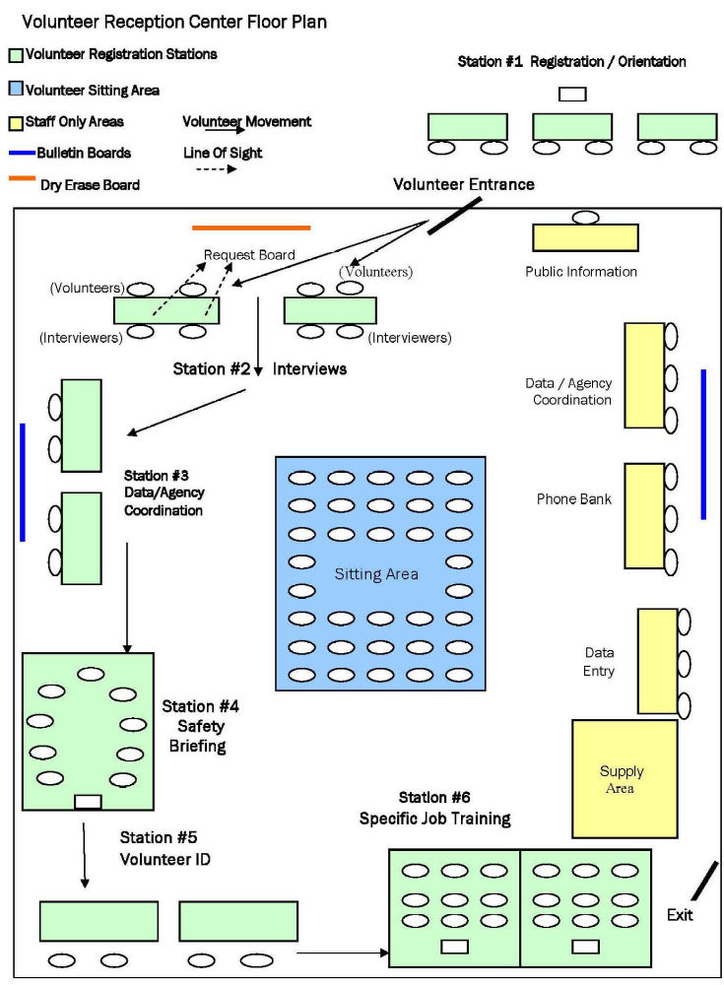

VRC Staff Tasks – VRC Director

Your job is to oversee the operation of the Volunteer Reception Center. You will:
- Clearly designate one entrance and one exit.
- Set up the room for efficient flow of volunteers and information.
- Brief and assign tasks to staff and volunteers of the center.
- Monitor the operation and make staffing changes when necessary.
- Maintain all records of safety and job training provided to volunteers, and hours worked in the VRC by employees and volunteers.
- Turn all records in to the County Budget Department weekly or at end of the activation.

You should meet and thank all volunteers who help in the VRC and instruct them to sign in and out on the Volunteer Sign-in / Sign-out Record daily. Instruct paid staff to sign in on the Employee Sign-in / Sign-out Record daily. In a fast paced disaster response, both paid and volunteer staff will need regular reminders to sign in and out.
Items needed:
- ID Badge
- Tables and chairs (see sample room layout for details)
- “Go Box” containing office supplies and forms to stock your VRC for the first 2-3 days
- Items on the Supplies and Equipment list
- Clipboard

Staff Tasks – Greeters
(Station #1, Registration)
Ideally you will be working with a partner, orienting volunteers inside and outside the volunteer entrance. Your job is to greet people with a friendly and firm demeanor, determine the purpose of their visit and direct them accordingly.

- If they are there to volunteer, thank them, give them a “Volunteer Instructions” sheet and ask them to fill out a registration form. When the form is completed, direct them to the next available interviewer at Station #2.
- If they are media personnel, direct them to the Public Information Officer.
- If they are disaster survivors, refer them to the appropriate relief organization.
- If they are bringing cleaning supplies, nonperishable food, etc., to donate, refer them to an agency that is accepting donated goods.

If there is a long wait, some volunteers may not understand the reason and may become impatient. Please thank everyone for volunteering, briefly explain the process and ask everyone to be patient or, if they prefer, to come back later.
Items needed:
- ID badge
- Sign (Station #1 Registration)
- Tables, clipboards, and/or chairs for volunteers to use for filling out their forms.
- Supply of “Volunteer Instructions” handouts explaining the VRC process.
- Supply of Disaster Volunteer Registration Forms
- Pens
- Flag or hat to summon runners

VRC Staff Tasks – Interviewers
(Station #2, Interviews)

Your job is to do a quick interview of the prospective volunteer and refer him/her to a job at an agency appropriate to his abilities and interests. Requests for volunteers will be posted on a board in front of you (behind the volunteers being interviewed) and will be erased as the needs are filled. If the VRC has a computer system, you might also receive a printed list of the current needs.
When a new volunteer approaches, ask for his/her registration form. With the volunteer, verify its completeness and accuracy, and use it as a guide from which to inquire more about the volunteer’s skills. At the conclusion of the interview, keep his registration form. When the volunteer accepts an assignment, complete a Referral form, filling in all information requested, give it to the volunteer and instruct him to report to Data Coordination (Station #3).
Before you signal the Greeter that you are ready for another interview, take a minute to jot down in the “Notes” section anything about the volunteer you feel is important and that the volunteer did not include on his registration form (a special skill, an obvious physical limitation, etc.) If your center decides to use the blind field labeled “Office Use Only*,” check the appropriate box. Place his registration form in the file.

Key points to remember are:

- Disaster registration differs from a “normal” volunteer intake – there is less time to try to fit each volunteer into an ideal assignment.
- Refer to the volunteer on the spot if possible – it may be impossible to contact him/her later. If the volunteer has special training or unusual skills that you think might be needed soon, ask him to wait in the sitting area and to check the volunteer request board for new requests for their specialized skills.
- Be sure to watch for volunteers who would work well in the Volunteer Reception Center. (It may seem self-serving, but if the VRC has sufficient staff and works effectively, the community will benefit!)
- It is likely that some volunteers will exhibit the stress of the disaster – they may be victims themselves. An extra measure of patience and understanding is needed.
- You may be called upon to train new volunteers to assist with the interviewing.
*The VRC Director should determine appropriate use of the “Office Use Only” field. It is intended to provide a customizable “blind” field in which special information can be noted about volunteers. If, for future referral of that volunteer, it would be helpful to know his general level of ability to work independently, boxes 1-5 could be coded:
- Learns quickly, able to supervise the activities of others;
- Would work well independently, good decision making skills;
- Needs some supervision and assistance with decision making;
- Needs close or constant supervision; and
- Has a mental, physical or emotional limitation to consider in making a referral.
Items needed:

- ID Badge for each interviewer
- 2-3 tables and 8-12 chairs (see floor plan)
- Sign (Station #2 Interviews)
- Supply of Referral forms
- Flag or hat to summon runners
- Pens
- File for maintaining Volunteer Registration Forms in alphabetical order

VRC Staff Tasks – Data/Agency Coordinator
(Station #3, Data/Agency Coordination)

When a volunteer brings you his/her Referral Form, pull the corresponding Request for Volunteers Form from the file. Enter his/her name and date of the referral on the bottom of the Request Form. Place your initials in the appropriate box on his Referral Form. Direct the volunteer to Station #4 for a Safety Briefing.
As you have time, call the agency contact to let him know who or how many volunteers have been referred. Confirm with the agency contact whether you should continue referring volunteers or close out the Request.

When a Request has been filled, raise your flag or put on the hat to call a runner and ask him to confirm that the request has been removed from the board.

Enter the date and reason the request was closed (completed, no longer needed, etc.) at the bottom of the Request form. If your Requests for Volunteers have been entered into a computer database, be sure to enter the date and reason the Request was closed as soon as possible. Place open Requests in one file and closed Requests in the other, alphabetically by agency.

You may have to call an agency contact to clarify the agency’s Request. When you speak with an agency contact, record the information on the Request form in the section called “Follow-up Contacts with Requesting Agency.”
Items needed:
- ID Badge for each staff member
- Sign (Station #3, Agency / Data Coordination)
- Two tables and four chairs
- Phone
- Two sets of files – one for open Requests for Volunteers and one for closed out Requests
- Pens
- Computer, if available, networked to the computers at the Phone Bank station
- Flag or hat to summon runners

VRC Staff Tasks – Phone Bank Staff
You will be handling two types of calls, those from agencies requesting volunteers and those from people wanting to volunteer. The information you record about each call must be complete and in sufficient detail to facilitate matching volunteers to the needs. DO take control of each call immediately. It is much more efficient to ask the questions in the order in which they appear on the form. (If the caller takes control you will find yourself scribbling in the margins and will not get all the required information).
When an agency calls to requests volunteers, fill out a Request for Volunteers form while you are speaking with the agency caller. If there is a computer available for entering the request into a database, Data Entry staff should enter the need as soon as possible, or could enter the data directly while speaking to the caller.

Next, call a runner by raising the flag at your station. Ask the Runner to post the volunteer request on the board in view of the Interviewers (Station #2) and then to give the Request for Volunteers form to the Data Coordinator (Station #3).

When people call to volunteer, thank them and give them the following registration options:

- They may register in person at the VRC, and will be given instructions when they arrive.
- They may register on-line, and will be e-mailed regarding possible assignments and given further instructions. If the caller represents a group that wishes to volunteer together, ask him to be patient while you determine where they can be of most help. It might take one day or several to match a volunteer with a need, especially if he is coming from out of town.
When a match (a mission) is found for that volunteer, e-mail or call him back. Ask him to print the registration form he completed on-line and schedule a time for him to come to the VRC to turn in his signed registration form and complete the registration process.
Items needed:
- An ID Badge for each staff member
- Sign (Phone Bank)
- Supply of Request for Volunteers forms
- Two tables and four chairs
- Phones
- Pens
- Flag or hat to summon a runner

VRC Staff Tasks – Data Entry

Your job is to enter the information from the Volunteer Registration and Request for Volunteers forms into the database so that an accurate record can be maintained of who participated in the recovery effort, what kinds of work they did and when it was performed.

After the initial influx of volunteers has subsided, you may have time to begin entering the referrals recorded on the Request for Volunteers forms and to close out the completed Requests. As needed by VRC staff, print updated lists of the unfilled Requests and ask a Runner to distribute copies to Phone Bank staff, Data Coordination, Interviewers and, if requested, the VRC Director.

Even if you are familiar with the software being used by the VRC, please ask for a brief orientation before beginning your first shift. Accuracy is more important than speed. The information you enter will be used to document the number of agencies and volunteers participating in the relief effort and the number of hours served.

If you have difficulty using the computer, please ask for help immediately. Do not attempt to fix the problem yourself.
Items needed:
- ID Badge
- Table and chairs
- Printer
- Pens
- Flag
- One or more computers (multiple computers should be networked to provide all users access to information on the status of volunteer requests and the availability of volunteers.)

VRC Staff Tasks – Safety Trainers
(Station #4, Safety Briefing)

Your job is to brief all new volunteers on what to expect at their job sites, how to be safe while volunteering and how to take good care of themselves after their experience. When a small group has gathered, thank the volunteers for offering to help. Pass around a clipboard with an attendance sheet and check to be sure that all participants have signed it.
Read the entire Safety Training sheet slowly, emphasizing the importance of following supervisors’ instructions at the worksite. Encourage everyone to attend a debriefing, if available, at the end of their shift. Ask if there are any questions. If a question arises to which you do not know the answer, put on the hat to summon a runner. Ask the runner to summon the VRC Director or other VRC staff to answer the question. At the conclusion of the briefing, direct volunteers to Station #5 Volunteer ID.
Attach a copy of the safety briefing script/handout to the attendance sheet for each class, file them in the folder and turn them in to the VRC Director daily.

Maintenance of these records is critical to help protect the Volunteer Reception Center, voluntary agencies and emergency management officials from liability, should a volunteer be injured on the job.
Items needed:
- ID Badge
- Sign (Station #4, Safety Training)
- 10 or more chairs, preferably in a semi-circle so everyone is facing the trainer
- Clipboard with attendance sheets
- Pen
- Stapler
- List of additional training required by specific worksites, training locations, and instructors
- Supply of Safety Training handouts
- Flag or hat to summon runners

VRC Staff Tasks – Volunteer ID Staff
(Station #5, Volunteer ID)

Thank all volunteers for coming out and ask to see their Referral forms. Clearly write on an ID wristband the name of the volunteer, dates he/she will be working, and the name of the agency to which the volunteer was referred, as shown on their Referral form. Place the ID wristband securely on the volunteer’s wrist.

Explain to the volunteers that the ID will be “good” only for the date(s) written on the band. Authorities may not permit them to enter any of the disaster impacted areas on any other day, without a current ID wristband. If volunteers plan to work more than one day, you may write the beginning and ending dates of their service.

Some volunteers will be required to take additional training for their particular work. When your briefing is concluded, direct those volunteers to Station #6, where specific job training is being provided. Direct all others to the exit or to transportation to their work sites.

If you need assistance, please raise your flag or put on the hat to summon a runner.
Items needed:

- ID Badge
- Two tables and four chairs
- Sign (Station #4, Volunteer ID Tags)
- Supply of volunteer ID wristbands
- Fine point permanent markers
- Scissors
- Flag or hat to summon runners

VRC Staff Tasks – Runners

Your job is to carry information from one station to another within the VRC. When a station needs you to pick up forms, restock their supplies or escort a volunteer from one place to another, they will signal you by raising a flag or putting on a hat at their station.

Please watch carefully for this signal and respond promptly, in order to keep the information and volunteers moving smoothly through the registration and referral process.
One Runner should be stationed at the board on which Requests for Volunteers are posted. As a volunteer is referred, place a tally mark or otherwise indicate next to that request the number of volunteers referred. This prevents referring too many volunteers to a request.
Runners posting new Requests for Volunteers on the board, should use only the markers provided and write neatly and large enough so that the interviewers can see the requests clearly. After posting the request on the board, give the Request form to the Data Coordinator (Station #3).
Items needed:
- ID Badge
- Dry erase marker or water soluble marker (Dry erase markers should not be used on a laminated “portable white board.”)
- Dry eraser or damp sponges

VRC Staff Tasks – Public Information Officer
(Public Information Table)

Your task is to work with any members of the media that come to the Volunteer Reception Center (VRC). If/when media arrive, greet them, and explain the process of the VRC. Have information available on when the VRC was established, how many volunteers have been processed and which organizations are receiving volunteers. If they wish to speak with a volunteer, approach the volunteer for them and ask if they are willing to speak to the media. Provide a more private area where the interview can take place.
Items needed:
- ID Badge
- Sign (Public Information)
- Table near the door for Public Information Office
- Public messages/brochures that are being distributed in the community about the incident and/or VRC.

Appendix F Volunteers and Oil Spill Response Brochure
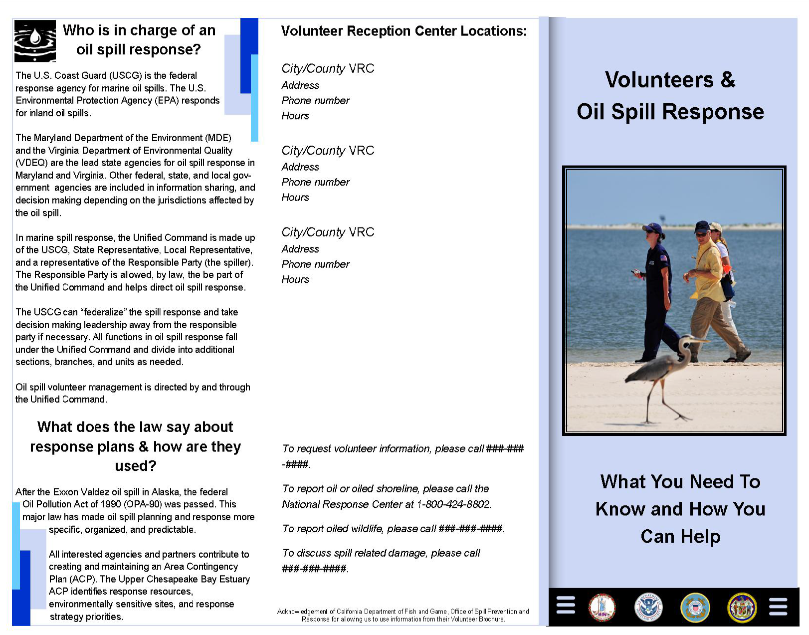
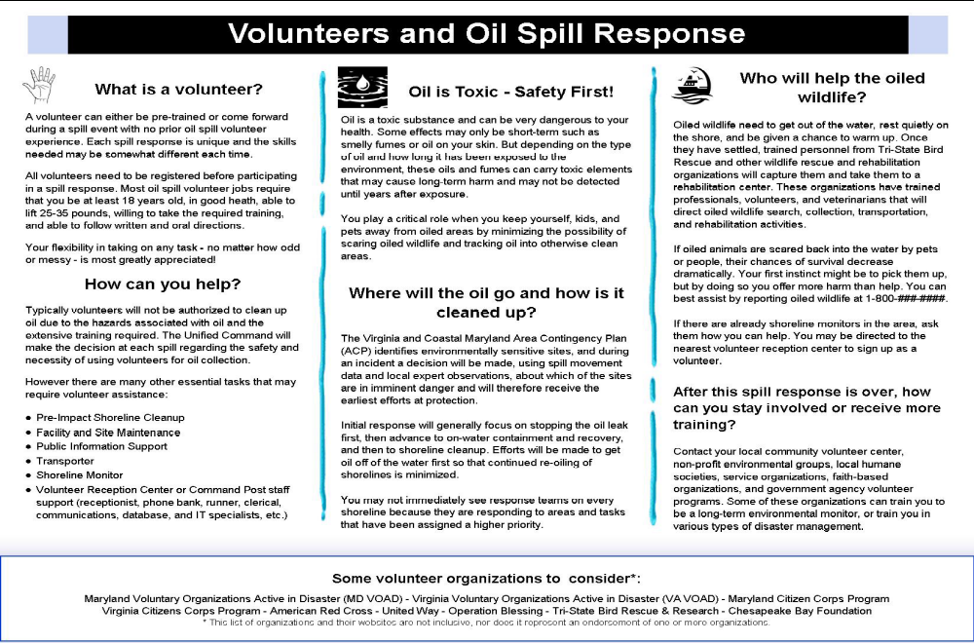

Appendix G Draft Media Release

East District Public Affairs
U.S. Coast Guard
News Release
Date: September XX, 2010

Contact: East District Public Affairs
(757) 398-6272

Coast Guard, local agencies continue oil spill clean-up efforts

CITY, State – An aggressive clean-up operation is underway in response to the approximate [amount] oil spill at [location] to secure the source, contain and recover the spilled oil, as well as ensure that the environment is minimally impacted. The Coast Guard, along with our partners, is appreciative of the overwhelming offers for support to the community. We appreciate the public’s desire to volunteer and understand their concern. We have provided some useful guidelines for the public with regards to clean-up efforts.

- Since safety of the public and incident responders is our number one priority, the public is advised to avoid contact with the oil and keeps pets on leashes away from beaches or areas where the product has accumulated, as their presence can hamper clean-up efforts and increase danger factors.

- Wildlife impacted by oil will beach themselves in order to warm up and rest. When wildlife sees people and pets on the beach, they perceive them as predators and will likely return to the water where hypothermia and re-oiling may occur. Therefore, the public should not to attempt to rescue oiled wildlife. Untrained individuals who attempt to rescue wildlife may cause the animal more harm than good and may injure themselves in the process. If oiled animals are scared back into the water by pets or people, their chances of survival decrease dramatically.

- Tri-State Bird Rescue and Research is the lead wildlife agency, their trained volunteers and staff are the only ones authorized to rescue and care for oiled wildlife.
- The public can best assist by reporting oiled wildlife by calling 1-800-XXX-XXXX. (confirm hotline number with VUL and Wildlife Branch)
- The responsible party (the spiller) is required to pay for the cleanup. They provide the cleanup contractors, referred to as Oil Spill Response Organizations (OSROs), to recover the spilled oil and clean up oiled shorelines. The personnel who conduct this work have received specialty training in hazardous materials handling and disposal.

- Trained crews are instructed in how to dispose of the oil and oily materials. The recovered oil must be carefully quantified to determine how much was removed from the environment. Then it is transported to a hazardous materials landfill or recycled. When oil is disposed of improperly, such as in household or public receptacles, this may lead to contamination of municipal water supplies.

- Volunteers must first register before participating in a spill response. They must be at least 18 years, in good health, capable of lifting 25-35 pounds and able to follow both written and oral directions. They must also be willing to attend any necessary training.

- A volunteer can either be pre-trained or come forward during a spill event with no prior oil spill volunteer experience. Each spill response is unique, and the skills needed may be somewhat different each time.

- Volunteering will not typically involve cleaning up oil. Oil is a toxic substance and dangerous if handled or disposed of improperly. Only trained personnel are authorized to conduct oil spill clean-up.

- However, there are many other important tasks that may require volunteer assistance: (check with VUL prior to specifying volunteer tasks)
    - Pre-Impact Shoreline Cleanup
    - Facility and Site Maintenance
    - Public Information Support
    - Transporter
    - Shoreline Monitor
    - Emergency Volunteer Center or Command Post staff support (receptionist, phone bank, runner, clerical, communications, database and IT specialists, etc.)

- In order to keep the public informed about possible volunteer opportunities, a Volunteer Hotline has been established at 800-XXX-XXXX.

ShareThis
Saving Lives and Guarding the Coast Since 1790.
The United States Coast Guard -- Proud History. Powerful Future.

Appendix H Draft ICS-204
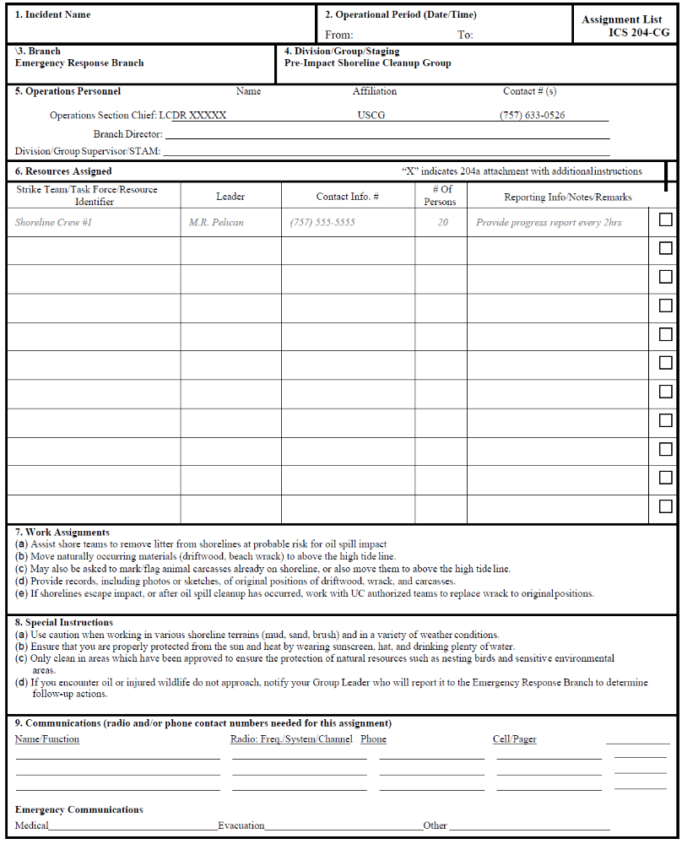
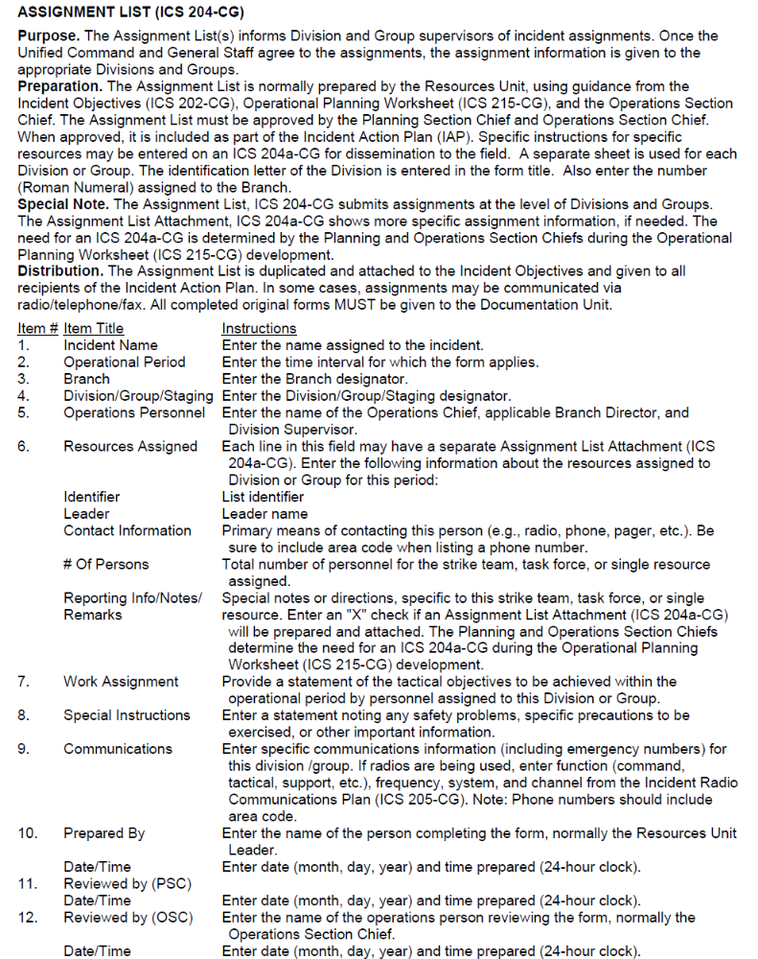

Appendix I ACRONYMS
ACP – Area Contingency Plan
AVO-Affiliated Volunteer Organizations
ASAP – As Soon As Possible
CBO – Community Based Organization
CERT – Community Emergency Response Team
CFR – Code of Federal Regulations
COVEOP – Commonwealth of Virginia Emergency Operations Plan
DECON – Decontamination
DFG – Department of Fish and Game
DIV – Division
DIVS – Division/Group Supervisor

EMS – Emergency Medical Services EOC – Emergency Operations Center ESF – Emergency Support Function
FOBS – Field Observers
FOSC – Federal On-Scene Coordinator
FSC – Finance/Administration Section Chief
GIS – Geographic Information System
HAZCOM – Hazard Communications
HAZMAT – Hazardous Materials
HAZWOPER – Hazardous Waste Operations and Emergency Response
IAP – Incident Action Plan IAW – In Accordance With IC – Incident Commander
ICP – Incident Command Post
ICS – Incident Command System
IMH – Incident Management Handbook
IMT – Incident Management Team
IT – Information Technologist
JIC – Joint Information Center

LCP – Local Contingency Plan
LGR – Local Government Representative
LNO – Liaison Officer
LOSC – Local On-Scene Coordinator
LSC – Logistics Section Chief
MEMA – Maryland Emergency Management Agency
MDE – Maryland Department of the Environment
MOU – Memorandum of Understanding
NCP – National Oil and Hazardous Substances Pollution Contingency Plan

NGO – Non-Government Organization
NPREP - National Preparedness for Response Exercise Program
NRDA – National Resource Damage Assessment
NRT – National Response Team
OES – Office of Emergency Services
OJT – On-the-Job Training
OPBD – Operations Branch Director
OPS – Operations
OSC – Operations Section Chief
OSHA – Occupational Safety and Health Administration
OSLTF – Oil Spill Liability Trust Fund
OSRO – Oil Spill Removal Organization
PEL – Permissible Exposure Limits
PIO – Public Information Officer
PPE – Personal Protection Equipment
PSC – Planning Section Chief
Reps – Representatives RESL – Resource Unit Leader RP – Responsible Party
RPIC – Responsible Person Incident Commander
RP/UC – Responsible Party/Unified Command

SCKN –Status/Check-in Recorder
SOFR – Safety Officer
SOSC – State On-Scene Coordinator
SPCA – Society for the Prevention of Cruelty to Animals
SSHP – Site Safety and Health Plan STAM – Staging Area Manager SITL – Situation Unit Leader STLCR – Strike Team Leader

UC – Unified Command

VC – Volunteer Coordinator
VDEM – Virginia Department of Emergency Management VDEQ – Virginia Department of Environmental Quality VOAD – Voluntary Organizations Active in Disaster
VOL – Volunteer
VMP – Volunteer Management Plan
VRC – Volunteer Reception Center
VRC-C – Volunteer Reception Center Coordinator
VU – Volunteer Unit
VUL – Volunteer Unit Leader

